**Hong Kong Orthopaedic Association**

**Adult Joint Reconstruction Chapter Lecture**

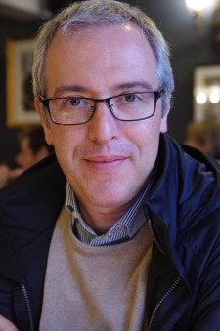

**Experience on Hip surgery**

Speaker: Dr Alessandro Massè, Associate Professor of Orthopaedics and Traumatology at the University of Torino and Director of the Unit of Orthopaedics and Traumatology at the II School of Medicine of the University of Torino

|  |  |
| --- | --- |
| 25 Jan 2016 6:00pm to 7:30pm | 26 Jan 2016 6:00pm to 7:30pm |
| Venue: Multimedium Room, 2/F, Blk S, UCH | **Venue: Seminar Room, F3, QEH** |
| 1.       Surgical dislocation technique for the treatment of acetabular fractures and femoral head fractures | 1.      Direct anterior approach:  How I have changed my view and landmarks from posterior to anterior approach |
| 2.       Management of hemodynamically unstable pelvic trauma | 2.    Instrument and implant consideration for direct anterior approach |
| 3.       Surgical hip dislocation for anatomic reorientation of slipped capital femoral epiphysis | 3.       Direct anterior approach with bikini incision |
| 4.       Do osteotomies of the proximal femur still have a role | 4.       Short stem: fashion or trends? |
| 5.       Anatomy and biomechanics of normal and abnormal hips |  |

CME/CPD accreditations: pending ; No registration is required

For reservation of car-park :  
UCH : Please email Ms Laila Au at [lailaau@ha.org.hk](mailto:lailaau@ha.org.hk)

QEH : Please email or fax to Ms Penny Hung by phone 35067119 or by Fax 35066638

Refreshment will be sponsored by Smith & Nephew

Organizers: Adult Joint Reconstruction Chapter, Hong Kong Orthopaedic Association

Department of Orthopaedics & Traumatology, United Christian Hospital

Department of Orthopaedics & Traumatology, Queen Elizabeth Hospital

