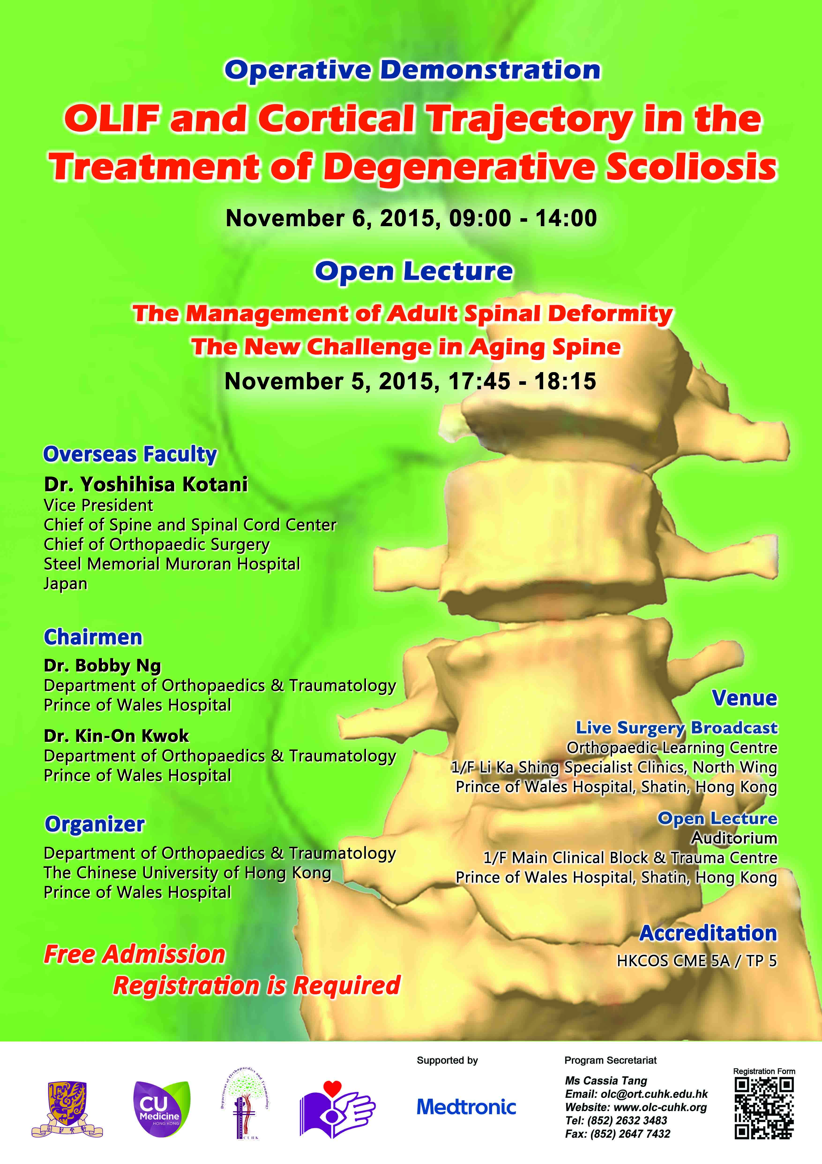

Registration Form

I would like to register for the following session(s). (please  )

 Operative Demonstration:
OLIF and Cortical Trajectory in the Treatment of Degenerative Scoliosis
November 6, 2015, 09:00-14:00
 Open Lecture:
The Management of Adult Spinal Deformity – The New Challenge in Aging Spine
November 5, 2015, 17:45 – 18:15

Contact Information (*must fill)
*Name: ( Dr.  Prof.)
(First Name) (Last Name)
*Position: Specialty:
*Department: *Hospital:
Correspondence Address:

Phone: Fax: *E-mail:
*Do you want to join OLC membership to receive notification of upcoming workshops? Yes No
Particulars
No. of years in Orthopaedics: HOT / BST: Year (if applicable)
Other specialist qualification, e.g. FRCS: (if applicable)

